FYP 1 Interim Report

by

Student Name
Student ID

Supervisor Name

Department of Electrical & Electronics Engineering

MAY 2022

ABSTRACT

An abstract is a short version of a report. It covers the report’s purpose, scope, methodology, results and conclusion. Abstracts should be no longer than one page. Avoid the use of bold or italic in the abstract. The dissertation must be written in acceptable and formal English. Students are encouraged to use brief and straightforward wordings, use passive voice and avoid using jargon as much as possible. Extended proposal/ interim report/ progress report should be in the form of double-sided printing. The hard-bound printed copy of the dissertation should be in the form of single sided printing. Table and figures should be single spaced and computer programs/source codes must be reduced to font size 8.

TABLE OF CONTENTS

ABSTRACT |  | iv
LIST OF FIGURES |  | vii
LIST OF TABLES |  | viii
CHAPTER 1: | INTRODUCTION | 1
 | 1.1 First Page in Each Chapter | 1
 | 1.2 Second Page in Each Chapter | 1
CHAPTER 2: | LITERATURE REVIEW | 1
 | 2.1 General Writing Format | 2
 | 2.1.1 Pagination | 2
 | 2.1.2 Equation in Text | 3
 | 2.2 Figures and Tables | 3
 | 2.3 Maximum Length | 5
CHAPTER 3: | METHODOLOGY | 6
 | 3.1 Citing an Author or Authors | 6
 | 3.2 Reference List | 7
 | 3.2.1 Journal Paper | 7
 | 3.2.2 Books | 8
 | 3.2.2 Electronic Source | 9
 | 3.3 EndNote Software | 10
CHAPTER 4: | RESULTS AND DISCUSSION | 6
 | 4.1 Citing an Author or Authors | 6
 | 4.2 Reference List | 7
 | 4.2.1 Journal Paper | 7
 | 4.2.2 Books | 8
 | 4.2.2 Electronic Source | 9
 | 4.3 EndNote Software | 10
CHAPTER 5: | CONCLUSION | 6
 | 5.1 Citing an Author or Authors | 6
 | 5.2 Reference List | 7
 | 5.2.1 Journal Paper | 7
 | 5.2.2 Books | 8
 | 3.2.2 Electronic Source | 9
 | 3.3 EndNote Software | 10
REFERENCES |  | 11
APPENDICES |  | 12

LIST OF FIGURES

Figure 2.1 | Infrared spectra of chitosan and ionogel | 4
Figure 2.2 | SEM observations of: (a) porous composite electrode; (bed) composite electrode filled by a photo-ionogel. Scale bar d is 1 mm on each picture. | 5
Figure 4.1 | Endnote with APA style | 12

LIST OF TABLES

Table 2.1 | Example of a table | 4
Table 2.2 | Example of a table with more than one line. The caption needs to be on top of the table and justified | 4
Table 2.3 | Maximum length | 5

CHAPTER 1

TITLE OF THE CHAPTER

1.1 First Page in Each Chapter

For the first page in every chapter the margin should follow: Top – 5cm, Left – 4cm, Right – 2.5cm and Bottom – 2.5cm. All text should be justify, 1.5 spacing between lines and 1 spacing between paragraphs. Use Times New Roman regular font-style, size 12 typed on a white A4 paper. Tab is used for the first line in every paragraph.

All headings should be in Times New Roman and bold. Title of the Chapter should be in capitals and in 14 font size while the primary, secondary and tertiary headings should be in title case and in 12 font size.

1.2 Second Page in Each Chapter

For the first page in every chapter the margin should follow: Top – 2.5cm, Left – 4cm, Right – 2.5cm and Bottom – 2.5cm. All text should be justify, 1.5 spacing between lines and 1 line spacing between paragraphs. Use Times New Roman regular font-style, size 12 typed on a white A4 paper. Tab is used for the first line in every paragraph.
Warning, turn ON formatting mark to see section break

CHAPTER 2

WRITING FORMAT

All final year students in UTP are required to undertake a Final Year Project (FYP) course, which is a design and/or research-based subject. This course is a compulsory element in all programmes offered in UTP. FYP is divided into two parts which are Final Year Project I (FYPI) and Final Year Project II (FYPII)

2.1 General Writing Format

The writing of the extended proposal/ interim report/ progress report and dissertation should adhere to the standard format as outlined in this template.

2.1.2 Pagination

All pages must be numbered in proper sequence from introduction to the end of the report including pages on figures, tables, computer programs and appendices. All front materials including certifications, abstract, list of tables and list of figure are numbered in small Roman numerals (e.g. i, ii, iii). For the main text, the page number should use 1,2,3,4… Page numbers appear by themselves and are not to be enclosed in parenthesis, hyphens or other decorative symbols. Page numbers must be positioned at the bottom and must be centered. Page number uses Times New Roman size 12.

2.1.2 Equation in Text

Mathematical equations must be spaced out; superscript and subscript must be clearly shown, and numbered. For example; the dielectric data obtained from the complex dielectric permittivity of ionogels based poly(methyl methacrylate) and metal-containing ionic liquids can be calculated using Equation 1 (Zehbe et al., 2016).

$ε^{*}\left(ω\right)=ε^{'}\left(ω\right)-iε''(ω)$ (1)

The specific capacitance (C) of silica-based ionogels can be calculated via the Equation 2,

$C=\frac{I_{avg}}{sA}$ (2)

where Iavg is the average current magnitude of the cathodic and anodic sweeps, s is the voltage scan rate and A is the total electrode area covered by the ionogel (Wang et al., 2016 ).

2.2 Figures and Tables

Tables and figures are considered part of the report if it is within the main text. If it is of the size that is less than a page, it should be inserted into the text near the point of reference with a 3 spacing from the text. Tables should be on the same page. Margin limits of figures and tables should be the same as the full-page text. All tables and figures should be numbered based on the chapter. Table heading should be positioned at the top and centered for caption with only one line as shown in Table 3.1. If the table has more than one line of caption, the caption must be justify as shown in Table 3.2.

Table 2.1: Example of a Table
Table Head | Table Column Head
Table Head | Table column subhead | Subhead | Subhead
text | text | text | text

Table 2.2: Example of a Table with More Than One Line. The Caption needs to be on Top of the Table and Justify.
Table Head | Table Column Head
Table Head | Table column subhead | Subhead | Subhead
text | text | text | text

The caption for figure should be positioned at the bottom and centred for one line and justified for more than 2 lines. For example, Figure 2.1 shows is the infrared spectra of pristine chitosan and ionogel after elimination of the IL. Arrows show dNH₂ (blue) at 1586 cm⁻¹ and the ethylenic bond (red) at 1563 cm⁻¹ (Guyomard-Lack, Buchtova´, Humbert, & Bideau, 2015).

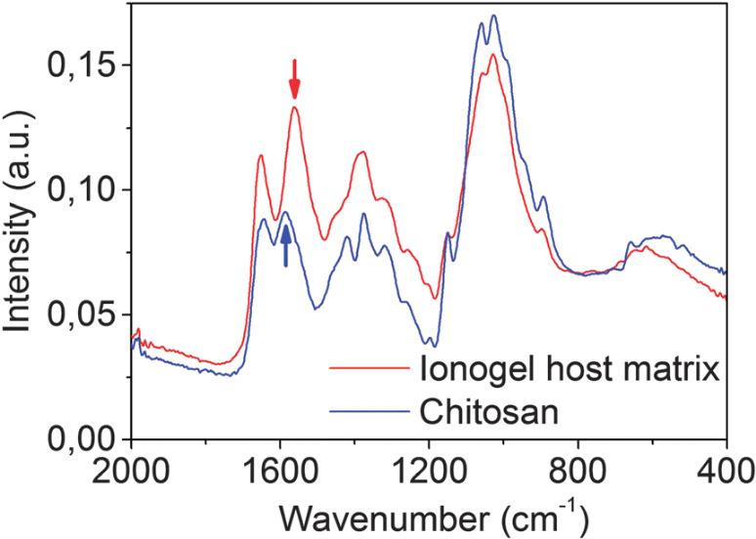
Figure 2.1: Infrared spectra of hitosan and ionogel.

In addition, Figure 2.2 shows typical SEM images that demonstrate the liquid precursor of the solid-state electrolyte is able to wet and fill the composite electrode porosity down to the interface with the aluminum collector (Aidoud et al., 2016).

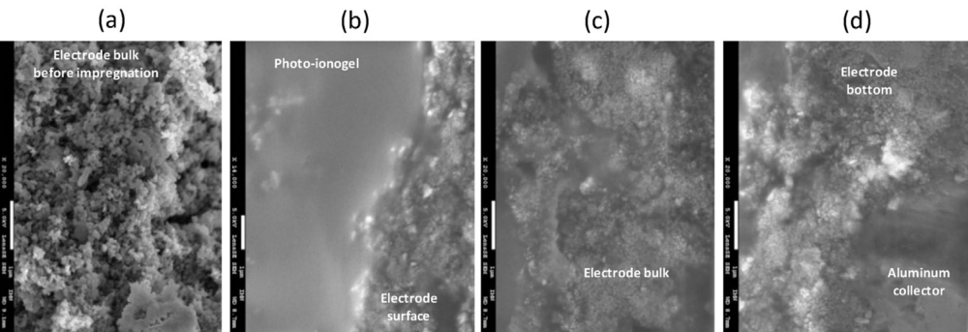
Figure 2.2: SEM observations of: (a) porous composite electrode; (bed) composite electrode filled by a photo-ionogel. Scale bar d is 1 mm on each picture.

2.3 Maximum Length

The maximum length of the report, excluding appendices is shown in Table 3.2.

Table 2.3: Maximum Length
Report | Pages
Extended Proposal | 10 pages
Interim Report | 20 pages
Progress Report | 30 pages
Dissertation | 50 pages

CHAPTER 3

REFERENCE STYLE

IEEE citation style is used primarily for electronics, engineering, telecommunications, computer science, and information technology reports. The three main parts of a reference are as follows:
- Author’s name listed as first initial of first name, then full last.
- Title of article, patent, conference paper, etc., in quotation marks.
- Title of journal or book in italics.
This system allows the reader to identify the information source at a glance. All
punctuation, dates, and page numbers depend on the type of reference cited, so follow the examples with care. Please note this style guide is wide ranging, but not all sources are identified. Further research may be required.

3.1 Citation Within the Text
The first step of the reference citation process is within the report itself. Each citation must be noted within the text through use of simple sequential numbers. A number enclosed in square brackets, placed in the text of the report, indicates the specific reference. Citations are numbered in the order in which they appear. Once a source has been cited, the same number is used in all subsequent references in the report. No distinction is made between electronic and print sources, except in the citation reference details.
Each reference number should be enclosed in square brackets on the same line as the text, before any punctuation, with a space before the bracket.
Examples
“. . .end of the line for my research [13].”
“The theory was first put forward in 1987 [1].”
“Scholtz [2] has argued. . . .”
“For example, see [7].”
“Several recent studies [3, 4, 15, 22] have suggested that. . . .”
Note: Authors and dates do not have to be written out after the first reference; use the bracketed number. Also, it is not necessary to write “in reference [2].” Just write “in [2].”
The preferred method to cite more than one source at a time is to list each reference in its own brackets, then separate with a comma or dash:
[1], [3], [5]
[1] – [5]
3.2 Reference List

To finish citing sources, a numbered list of references must be provided at the end of the paper. The list is comprised of the sequential enumerated citations, with details, beginning with [1], and is not alphabetical.

Page Format
- Place references flush left
- Single-space entries, double-space between.
- Place number of entry at left margin, enclose in brackets.
- Indent text of entries.

The following examples demonstrate the format for a variety of electronic and print
sources. These citations are ones in widest use. Not everything is listed.

3.2.1 Electronic Documents
E-books
[1] L. Bass, P. Clements, and R. Kazman, Software Architecture in Practice, 2nd ed.
Reading, MA: Addison Wesley, 2003. [E-book] Available: Safari e-book.

Article in Online Encyclopedia
[2] D. Ince, “Acoustic coupler,” in A Dictionary of the Internet. Oxford University
Press, [online document ], 2001. Available: Oxford Reference Online,
http://www.oxfordreference.com [Accessed: May 24, 2007].

Journal Article Abstract (accessed from online database)
[1] M. T. Kimour and D. Meslati, “Deriving objects from use cases in real-time
embedded systems,” Information and Software Technology, vol. 47, no. 8, p.
533, June 2005. [Abstract]. Available: ProQuest,
http://www.umi.com/proquest/. [Accessed November 12, 2007].

Journal Article in Scholarly Journal (published free of charge on the Internet) [2] A. Altun, “Understanding hypertext in the context of reading on the web:
Language learners’ experience,” Current Issues in Education, vol. 6, no. 12,
July, 2005. [Online serial]. Available:
http://cie.ed.asu.edu/volume6/number12/ . [Accessed Dec. 2, 2007].

Newspaper Article from the Internet
[3] C. Wilson-Clark, “Computers ranked as key literacy,” The Atlanta Journal
Constitution, para. 3, March 29, 2007. [Online], Available:
http://www.thewest.com.au . [Accessed Sept. 18, 2007].

3.2.2 Internet Documents
Professional Internet Site
[1] European Telecommunications Standards Institute, “Digital Video Broadcasting
(DVB): Implementation guide for DVB terrestrial services; transmission
aspects,” European Telecommunications Standards Institute, ETSI-TR-101,
2007. [Online]. Available: http://www.etsi.org. [Accessed: Nov. 12, 2007].

General Internet Site
[2] J. Geralds, “Sega Ends Production of Dreamcast,” vnunet.com, para. 2, Jan. 31,
2007. [Online]. Available: http://nli.vnunet.com/news/1116995. [Accessed
Sept. 12, 2007].
Personal Internet Site
[3] G. Sussman, “Home Page-Dr. Gerald Sussman,” July, 2002. [Online].
Available: http://www.comm.edu.faculty/sussman/sussmanpage.htm.
[Accessed Nov. 14, 2007].

Email
[4] J. Aston. “RE: new location, okay?” Personal email (July 3, 2007).

Internet Newsgroup
[5] G. G. Gavin, “Climbing and limb torsion #3387,” USENET: sci.climb.torsion,
August 19, 2007. [Accessed December 4, 2007].

Microform
[6] W. D. Scott, Information Technology in the US. [Microform]. W. D. Scott &
Co., Canberra: Department of Science and Technology, 2004.

Computer Game
[7] The Hobbit: The prelude to the Lord of the Rings. [CD-ROM]. United
Kingdom: Vivendi Universal Games, 2003.

Software
[8] Thomson ISI, Endnote 7. [CD-ROM]. Berkeley, CA: ISI ResearchSoft, 2006.

3.2.3 Lecture
[1] S. Bhanndahar. ECE 4321. Class Lecture, Topic: “Bluetooth can’t help you.”
School of Electrical and Computer Engineering, Georgia Institute of
Technology, Atlanta, GA, Jan. 9, 2008.

3.2.4 Print Documents
Books
Single Author
[1] W. K. Chen, Linear Networks and Systems. Belmont, CA: Wadsworth Press,
2003.
Edited Book
[2] J. L. Spudich and B. H. Satir, Eds., Sensory Receptors and Signal Transduction.
New York: Wiley-Liss, 2001.

Selection in an Edited Book
[3] E. D. Lipson and B. D. Horwitz, “Photosensory reception and transduction,”
in Sensory Receptors and Signal Transduction, J. L. Spudich and B. H. Satir,
Eds. New York: Wiley-Liss, 2001, pp-1-64.

Three or More Authors
[4] R. Hayes, G. Pisano, and S. Wheelwright, Operations, Strategy, and Technical
Knowledge. Hoboken, NJ: Wiley, 2007.

Book by an Institutional or Organizational Author
[5] Council of Biology Editors, Scientific Style and Format: The CBE Manual for
Authors, Editors, and Publishers, 6th ed., Chicago: Cambridge University
Press, 2006.

Manual
[6] Bell Telephone Laboratories Technical Staff, Transmission System for
Communication, Bell Telephone Lab, 2005.

Application Note
[7] Hewlett-Packard, Appl. Note 935, pp.25-29.

Note: Titles of unpublished works are not italicized or capitalized. Capitalize only
the first word.

Technical Report
[8] K. E. Elliott and C. M. Greene, “A local adaptive protocol,” Argonne National
Laboratory, Argonne, France, Tech. Report. 916-1010-BB, 7 Apr. 2007.

Patent/Standard
[9] K. Kimura and A. Lipeles, “Fuzzy controller component,” U. S. Patent 14,
860,040, 14 Dec., 2006.

Data Sheet
[10] Texas Instruments, “High speed CMOS logic analog multiplexers
/demultiplexers,” 74HC4051 datasheet, Nov. 1997 [Revised Sept.2002].

Government Publication
[11] National Aeronautics and Space Administration, NASA Pocket Statistics.
Washington, DC: Office of Headquarters Operations, 2007.

Paper Published in Conference Proceedings
[12] J. Smith, R. Jones, and K. Trello, “Adaptive filtering in data communications
with self improved error reference,” In Proc. IEEE International Conference
on Wireless Communications ’04, 2004, pp. 65-68.

Papers Presented at Conferences (unpublished)
[13] H. A. Nimr, “Defuzzification of the outputs of fuzzy controllers,” presented
at 5th International Conference on Fuzzy Systems, Cairo, Egypt, 2006.

Thesis or Dissertation (unpublished)
[14] H. Zhang, “Delay-insensitive networks,” M. S. thesis, University of Chicago,
Chicago, IL, 2007.

Article in Encyclopedia, Signed
[15] O. Singh, “Computer graphics,” in McGraw-Hill Encyclopedia of Science
and Technology, New York: McGraw-Hill, 2007, pp. 279-291.

3.2.5 Journal Articles
Article in Journal (paginated by annual volume)
[8] K. A. Nelson, R. J. Davis, D. R. Lutz, and W. Smith, “Optical generation of
tunable ultrasonic waves,” Journal of Applied Physics, vol. 53, no. 2, Feb., pp.
1144-1149, 2002.

Article in Professional Journal (paginated by issue)
[9] J. Attapangittya, “Social studies in gibberish,” Quarterly Review of
Doublespeak, vol. 20, no. 1, pp. 9-10, 2003.

Article in Monthly or Bimonthly Periodical
[10] J. Fallows, “Networking technology,” Atlantic Monthly, Jul., pp. 34-36, 2007.

Article in Daily, Weekly, or Biweekly Newspaper or Magazine
[11] B. Metcalfe, “The numbers show how slowly the Internet runs today,”
Infoworld, 30 Sep., p. 34, 2006.

3.3 Citation Software

Students are recommended to use Citation software such as EndNote / Mendeley to manage the references. Select IEEE as the as the Output Style

REFERENCES

[1] W. K. Chen, Linear Networks and Systems. Belmont, CA: Wadsworth Press,
2003.
[2] J. L. Spudich and B. H. Satir, Eds., Sensory Receptors and Signal Transduction.
New York: Wiley-Liss, 2001.
[3] E. D. Lipson and B. D. Horwitz, “Photosensory reception and transduction,”
in Sensory Receptors and Signal Transduction, J. L. Spudich and B. H. Satir,
Eds. New York: Wiley-Liss, 2001, pp-1-64.

APPENDICES
APPENDIX A: Common Mistakes
1) Avoid underline in text and title
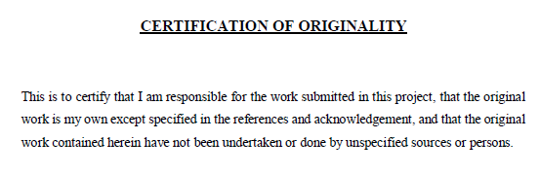
2) Do not bold “Figure”
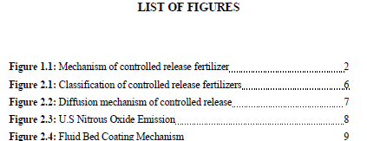
3) Avoid italic in text and title. Page number not following the right format
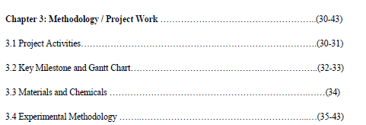
4) Chapter and title should be in different lines.
